|  |  |  |
| --- | --- | --- |
| **Input** | | **Output** |
| **A** | **B** | **F** |
| 0 | 0 | 0 |
| 0 | 1 | 0 |
| 1 | 0 | 0 |
| 1 | 1 | 1 |

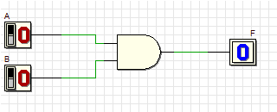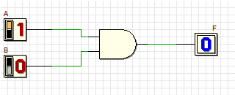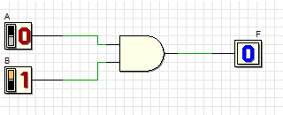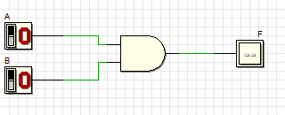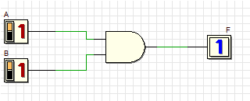

**Truth Table 1**

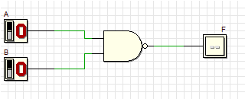

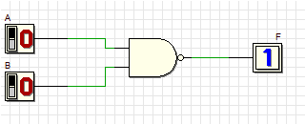

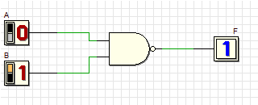

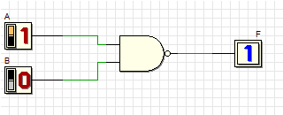

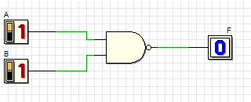

|  |  |  |
| --- | --- | --- |
| **Input** | | **Output** |
| **A** | **B** | **F** |
| 0 | 0 | 1 |
| 0 | 1 | 1 |
| 1 | 0 | 1 |
| 1 | 1 | 0 |

**Truth Table 2**

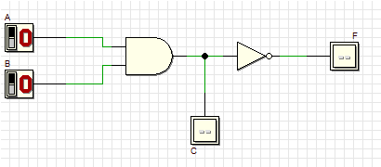

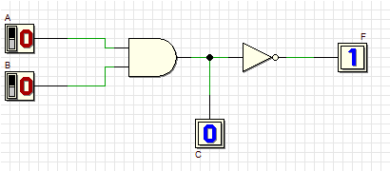

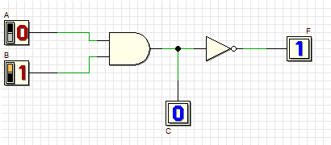

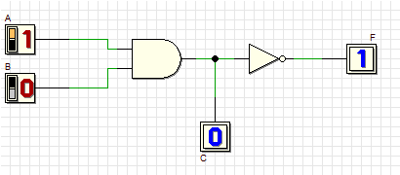

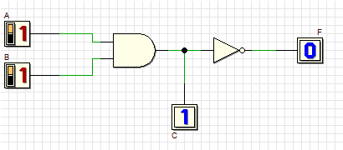

|  |  |  |  |
| --- | --- | --- | --- |
| **A** | **B** | **C** | **F** |
| 0 | 0 | 0 | 1 |
| 0 | 1 | 0 | 1 |
| 1 | 0 | 0 | 1 |
| 1 | 1 | 1 | 0 |

**Truth Table 3**

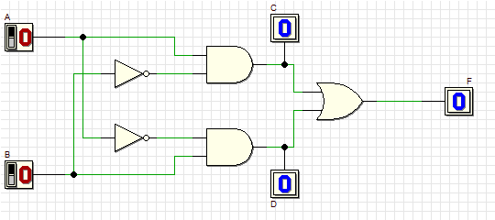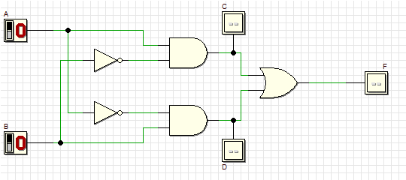

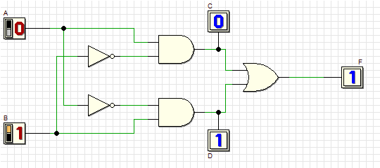

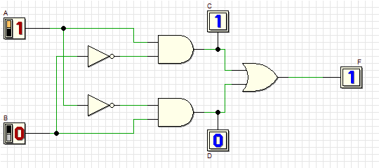

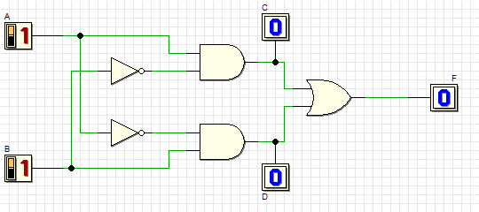

**Truth Table 4**

|  |  |  |  |  |
| --- | --- | --- | --- | --- |
| **A** | **B** | **C** | **D** | **F** |
| 0 | 0 | 0 | 0 | 0 |
| 0 | 1 | 0 | 1 | 1 |
| 1 | 0 | 1 | 0 | 1 |
| 1 | 1 | 0 | 0 | 0 |



|  |  |  |
| --- | --- | --- |
| **Input** | | **Output** |
| **A** | **B** | **F** |
| 0 | 0 | 0 |
| 0 | 1 | 0 |
| 1 | 0 | 0 |
| 1 | 1 | 1 |

**Truth Table 5**











|  |  |  |  |
| --- | --- | --- | --- |
| **A** | **B** | **C** | **F** |
| 0 | 0 | 0 | 1 |
| 0 | 1 | 0 | 1 |
| 1 | 0 | 0 | 1 |
| 1 | 1 | 1 | 0 |

**Truth Table 6**

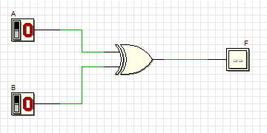

**Truth Table 7**

|  |  |  |  |  |
| --- | --- | --- | --- | --- |
| **A** | **B** | **C** | **D** | **F** |
| 0 | 0 | 0 | 0 | 0 |
| 0 | 1 | 0 | 1 | 1 |
| 1 | 0 | 1 | 0 | 1 |
| 1 | 1 | 0 | 0 | 0 |